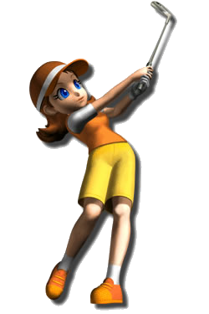
2024
TROUT LAKE LADIES LEAGUE
MEMBERSHIP FORM
Our league dues for the Trout Lake Ladies League are $40.00 for the season. Each week, we will have a daily game fee of $3.00 for prizes, and birdies/chip in’s. Please print out, complete the membership form, and MAIL it along with a check to: Trout Lake Golf Club, 3800 Hwy 51 North, Arbor Vitae, WI 54568. Attention: Wendy Shoemaker Please make checks payable to: Trout Lake Ladies League. Membership forms and dues must be received no later than May 28th, 2024, and must be MAILED to the golf course
Also, if you know anyone that wants to join us for the 2024 season, either share this form with them OR go to our website at troutlakegolf.com (under ladies league) and have them download it. Any other questions, have them call Scott Howard at 715-385-2189.

Name:________________________________________________________________________
Address:______________________________________________________________________
_______________________________________________________________________
Summer phone number:__________________________________________________________
Email address:__________________________________________________________________
If you are a new member, how did you learn about our golf league or who sponsored you?
_______________________________________________________________________________
If you are opposed to having your picture in the paper or on-line OR do not want your name in the paper, please check here. __________

Paid, ck number _________________ Date of payment:_________________________________

